Week 2 Data Analysis Report
Cairo Air Quality Forecasting: five districts, 1,096 days (2023-09-01 to 2026-08-31)
Task | Owner | Contribution
Task 1 | Mohamed Amr | Statistical hypothesis testing & correlation analysis
Task 2 | Abdelrahman Rafiq | STL decomposition, AQI labels, wind encoding
Task 3 | Abdelrahman Ashraf | Spatial interpolation, upwind/downwind and interaction features
Task 4 | Yousif Sherif | Satellite validation & definitive feature matrix
Task 5 | Yousif Mamdouh | Seasonal spatial patterns & feature-importance pre-screening
Task 6 | Abdullah Alaa | Weather-pollution dashboard, weekday/weekend analysis, report & final dataset

Executive summary
- Districts differ significantly for PM2.5, PM10, NO2 and SO2 (Kruskal-Wallis p < 0.001 for all four), so one city-wide model would average away real local structure.
- Seasonality is strong. PM10 shifts significantly in the Khamsin season in all five districts, and PM2.5 is higher in winter than in summer in four of five districts (October is the exception).
- Wind speed is the main weather driver (Spearman r = -0.69 with SO2 and -0.59 with NO2 pooled). Pressure is positively and temperature negatively associated with NO2/SO2.
- Health risk is common. 12-31% of days per district are Unhealthy or worse. No day is Good or Hazardous, and only 5 days are Very Unhealthy, so the classification target is heavily imbalanced.
- Satellite NO2 carries signal (r = 0.40-0.60 vs surface NO2). Satellite SO2 and CO do not (r < 0.16) and are dropped.
- Deliverable for Week 3: daily_features_v2.parquet, 5,480 rows x 105 columns, built from the final drop list, with the rolling averages recomputed on previous days only.

1. Statistical Analysis
Source: Task 1, Mohamed Amr. Significance level α = 0.05 throughout.

1.1 Differences between districts
One-way ANOVA (means) and the Kruskal-Wallis test (ranks, no normality assumption) were applied to each pollutant, with H0 = all five districts share the same distribution. Significant Kruskal-Wallis results were followed by Dunn's post-hoc test with Holm correction.
Pollutant | ANOVA F | ANOVA p | Kruskal-Wallis H | K-W p | Post-hoc (Dunn-Holm)
PM2.5 | 121.47 | < 0.001 | 638.59 | < 0.001 | Most pairs differ. Helwan vs Shobra does not (p = 0.775)
PM10 | 39.98 | < 0.001 | 183.21 | < 0.001 | New Cairo and Shobra differ from all others. Downtown, Helwan, October are similar
NO2 | 601.18 | < 0.001 | 2115.58 | < 0.001 | Every pair differs (all p < 0.001)
SO2 | 616.05 | < 0.001 | 2703.83 | < 0.001 | Every pair differs (all p < 0.001)
Meaning: pollution is not spatially uniform. NO2 and SO2 are the most district-specific, which supports district-aware features (station_id, road and industrial context). The tests show that districts differ, not why.

1.2 Seasonal regimes
PM10, Khamsin (Mar-May) vs non-Khamsin, Mann-Whitney U:
District | U statistic | p-value | Significant
Downtown | 123,301.5 | 0.0258 | Yes
Helwan | 130,965.5 | < 0.001 | Yes
New Cairo | 129,172.0 | < 0.001 | Yes
October | 133,051.5 | < 0.001 | Yes
Shobra | 123,007.5 | 0.0304 | Yes

PM2.5, winter (Dec-Feb) vs summer (Jun-Aug), Mann-Whitney U (all p < 0.001):
District | Winter median | Summer median | U statistic | Higher in
Downtown | 60.01 | 41.99 | 62,774.5 | Winter
Helwan | 54.23 | 42.70 | 50,495.0 | Winter
New Cairo | 46.57 | 34.44 | 55,606.0 | Winter
October | 33.49 | 40.42 | 28,258.5 | Summer
Shobra | 61.29 | 36.99 | 68,303.0 | Winter
Meaning: the seasonal flags already in the dataset (is_Khamsin_season, season) correspond to statistically significant shifts, so they are valid features. October behaves differently (higher PM2.5 in summer), another reason to keep district identity in the model.

1.3 Weather-pollution correlations (Spearman, per district)
Correlations with |r| > 0.4 were flagged as strong drivers. The strongest per-district results:
Pair | Downtown | Helwan | New Cairo | Shobra
SO2 vs wind speed | -0.75 | -0.66 | -0.63 | -
NO2 vs wind speed | - | -0.67 | - | -
NO2 vs temperature | -0.55 | -0.48 | -0.48 | -
SO2 vs temperature | - | - | - | -0.60
NO2 vs surface pressure | 0.53 | 0.46 | - | 0.53
SO2 vs surface pressure | - | - | - | 0.45
"-" = no strong correlation (|r| > 0.4) flagged for this pair. PM10 vs surface pressure in October: r = -0.44.
Wind speed, temperature and surface pressure produce most of the strong correlations; relative humidity and precipitation do not. These are associations, not causal effects.
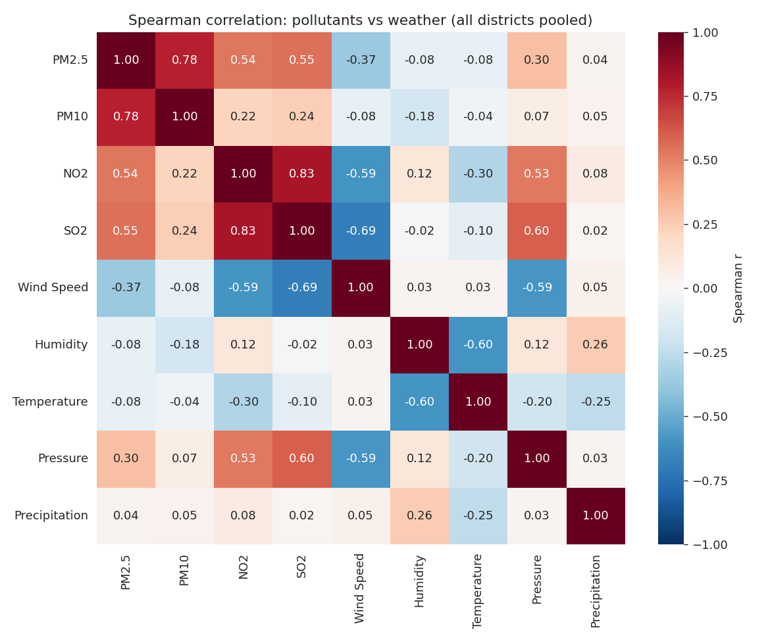
Figure 1. Pooled Spearman correlation matrix (all districts), computed from the Week 2 dataset for the dashboard heatmap.

2. Temporal Decomposition
Source: Task 2, Abdelrahman Rafiq. STL decomposition was run on pm2_5_corrected and pm10 for each district with weekly (period = 7) and annual (period = 365) cycles. Helwan PM2.5 uses a multiplicative model (seasonal amplitude grows with the trend); the other series use an additive model.

2.1 Trend, seasonality and residuals
District | PM2.5 trend | PM10 trend | Winter seasonal addition | Key residual drivers
Downtown | 59 → 45 µg/m³ | 52 → 35 | +80 to +100 | Winter pollution shocks (up to +75)
Helwan | 46 → 51 (rising) | 60 → 42 | +100 to +140 | Industrial emissions and dust (up to +120)
New Cairo | 45 → 39 | 43.5 → 33 | +75 to +100 | Early-year and winter spikes
6th of October | 37.5 → 42 | 61 → 44 | +75 to +150 | Spring dust (Khamsin), -150 to +150
Shobra | 54 → 43.5 | 48 → 35.5 | about +100 | Local combustion and spring dust
Trend ranges are from roughly late 2023 to late 2026. Seasonal additions are in µg/m³ (PM10 winter peaks).
- Trend: PM2.5 is falling in Downtown, New Cairo and Shobra after a 2024 peak, and rising slowly in Helwan and October. PM10 declines in all five districts by late 2026.
- Seasonality: winter (Dec-Jan) dominates the annual cycle. Weekly oscillations are smaller, roughly ±20 µg/m³ for PM2.5.
- Residuals: zero-centred, with large positive spikes in winter stagnation and spring dust events. These unexplained spikes are the hardest for any model to predict.
The following figures illustrate the complete STL decomposition process for stations (Helwan and Downtown). The full set of STL component breakdowns for all 5 monitoring stations and target pollutants (PM2.5 and PM10) is available in the project repository notebook.
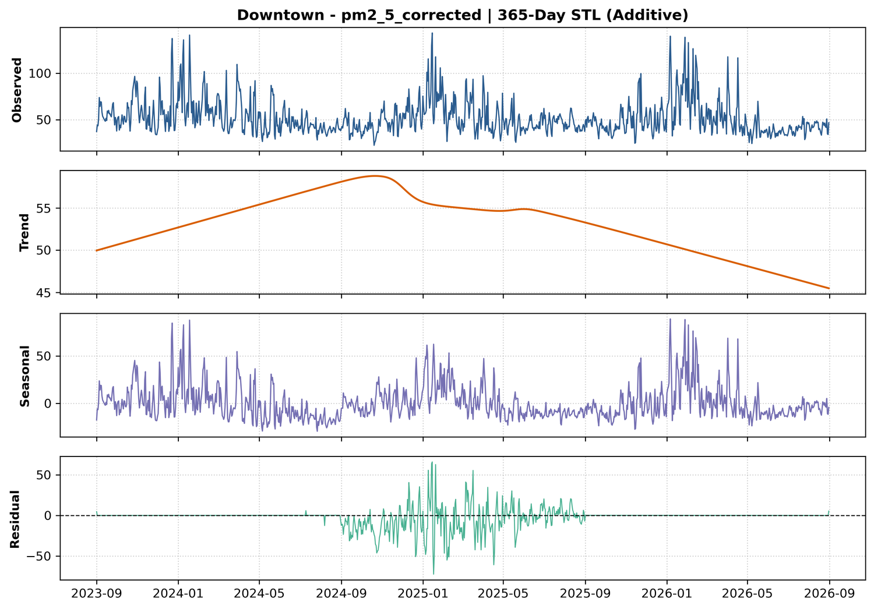
Figure 2. Downtown PM2.5 (corrected), 365-day STL, additive model: observed, trend, seasonal and residual.
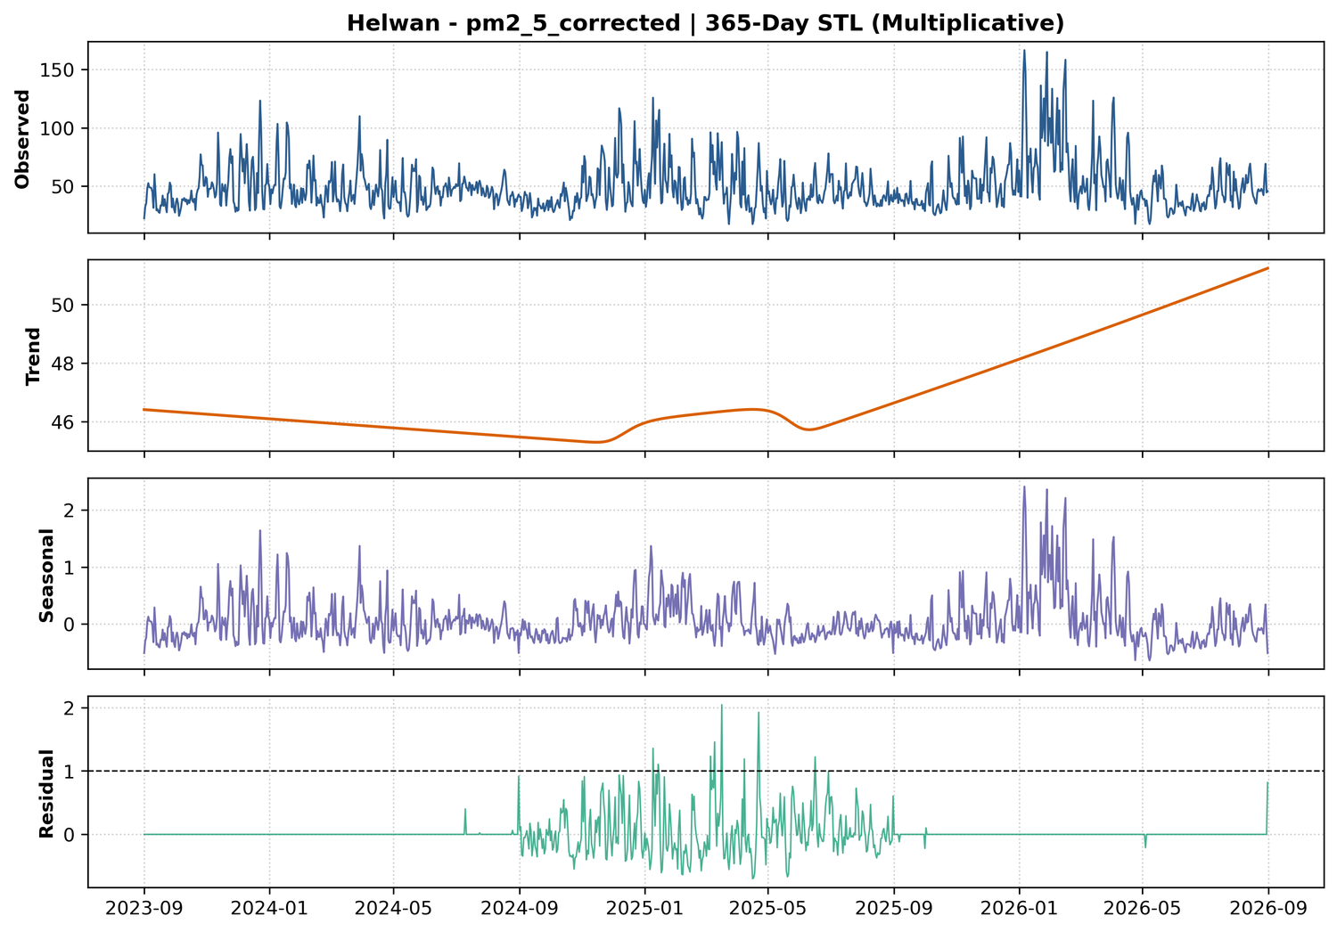
Figure 3. Helwan PM2.5 (corrected), 365-day STL, multiplicative model.

2.2 AQI classification
aqi_category applies US EPA breakpoints to pm2_5_corrected, and is_health_risk = 1 for Unhealthy or worse.
Category | PM2.5 range (µg/m³)
Good | 0 - 12.0
Moderate | 12.1 - 35.4
Unhealthy for Sensitive Groups | 35.5 - 55.4
Unhealthy | 55.5 - 150.4
Very Unhealthy | 150.5 - 250.4
Hazardous | > 250.5

Class distribution per district (% of days; counts computed from the final dataset):
District | Good | Moderate | USG | Unhealthy | Very Unhealthy | Hazardous | Health-risk days
Downtown | 0 | 11.1 | 57.8 | 31.1 | 0 | 0 | 31.1%
Helwan | 0 | 23.5 | 49.9 | 26.3 | 0.3 (3 days) | 0 | 26.6%
New Cairo | 0 | 44.3 | 42.5 | 13.2 | 0 | 0 | 13.2%
October | 0 | 52.0 | 35.6 | 12.4 | 0 | 0 | 12.4%
Shobra | 0 | 22.7 | 49.7 | 27.4 | 0.2 (2 days) | 0 | 27.6%

- Observed Distribution:
  - Very Unhealthy: 5 instances out of 5,480 (~0.091%): Helwan 3 and Shobra 2.
  - Hazardous: 0 instances (0.000%).
- Class imbalance: the upper AQI categories are extremely rare, so the six-class target is heavily imbalanced.
- Implication for Week 3: classification models and risk predictors should not rely on standard cross-entropy loss or unweighted accuracy. Suitable techniques include:
  - Class Weighting: Assigning significantly higher loss penalties to misclassifying minority classes.
  - Resampling: Using SMOTE, oversampling rare classes, or focal loss functions.
  - Target Reformulation: Grouping rare extreme classes into broader buckets (e.g., evaluating is_health_risk as a binary flag where 1 = Unhealthy or above, which combines Unhealthy, Very Unhealthy, and Hazardous into a single more frequent target class).
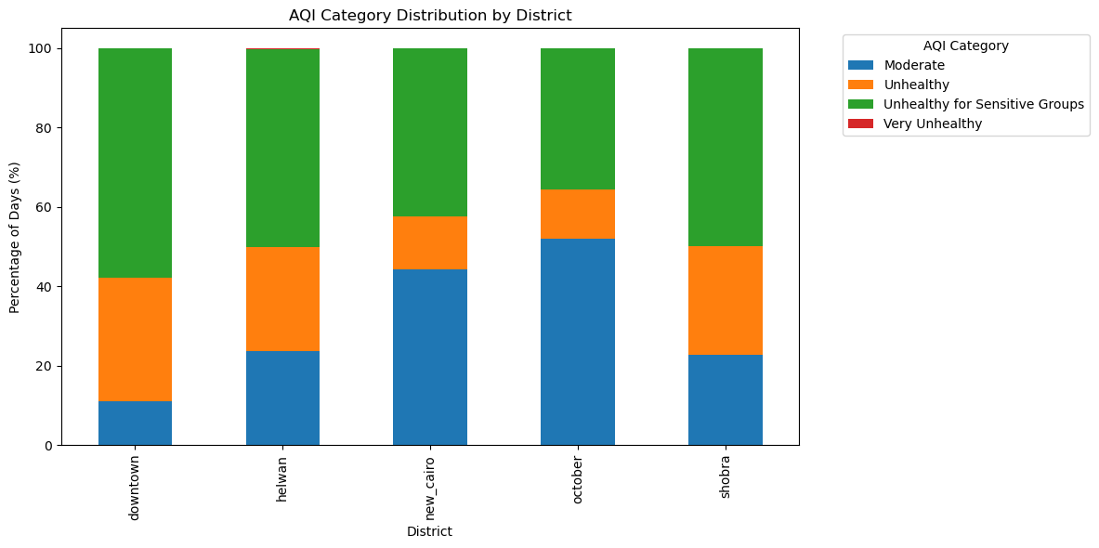
Figure 4. AQI category distribution by district (Task 2).
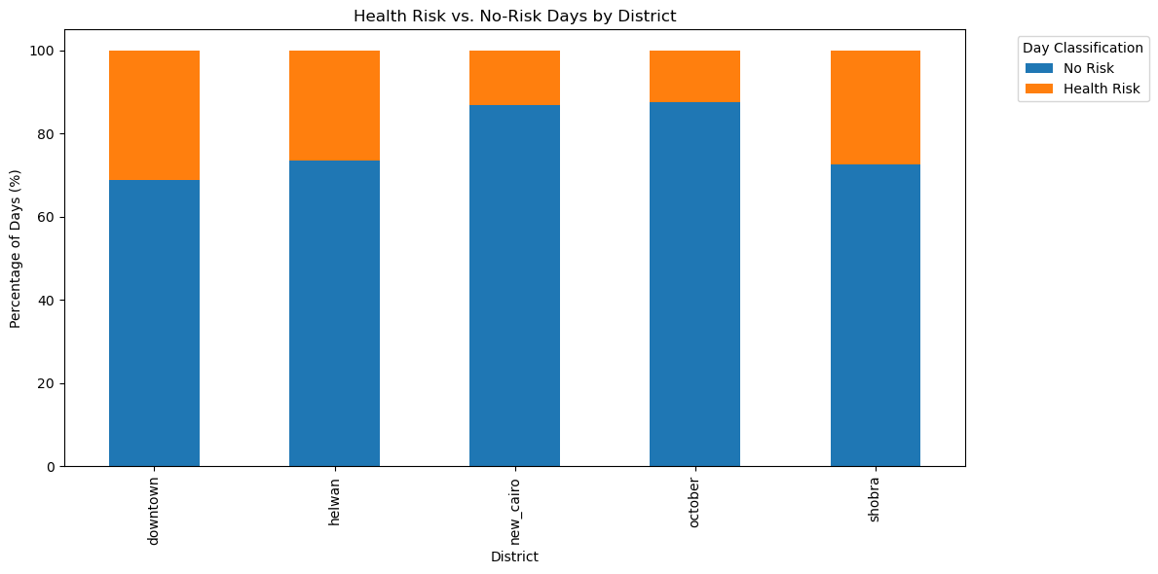
Figure 5. Health-risk vs no-risk days by district (Task 2).

2.3 Wind direction encoding
wind_dir_sin = sin(θ·π/180) and wind_dir_cos = cos(θ·π/180) replace all raw wind-direction columns, removing the 359°/1° discontinuity of a circular variable.

3. Spatial Analysis & New Features
Source: Task 3, Abdelrahman Ashraf. District coordinates are those used for the Open-Meteo requests. wind_dir_sin/cos use the meteorological convention (direction the wind blows from, clockwise from north); the overall mean of 340° (NNW) matches Cairo's prevailing wind.

3.1 Spatial IDW interpolation check
Downtown PM2.5 was estimated each day from the other four districts using inverse distance weighting (haversine distance, power p = 2) and compared with the actual Downtown series (pm2_5_corrected; no raw OpenAQ column exists in the file).
Estimator | MAE (µg/m³) | RMSE | Bias | r
IDW p = 2 (headline) | 5.16 | 6.63 | -4.02 | 0.960
IDW p = 1 | 6.70 | 8.38 | -5.72 | 0.944
IDW p = 3 | 4.73 | 6.33 | -2.96 | 0.961
Simple mean of 4 districts | 8.81 | 11.07 | -7.51 | 0.899
Shobra only | 4.81 | 6.66 | -2.15 | 0.958
Persistence (yesterday) | 9.83 | 14.71 | -0.01 | 0.684
Climatology (mean) | 13.51 | 18.50 | 0.00 | -

Leave-one-out IDW (p = 2) per district: Shobra MAE 4.59 / r 0.956, Downtown 5.16 / 0.960, Helwan 9.06 / 0.790, New Cairo 9.78 / 0.862, October 14.43 / 0.595.
- Proximity is meaningful around Downtown, Shobra and New Cairo: IDW beats persistence, climatology and the plain district mean.
- IDW is essentially Shobra plus a small correction. Shobra carries 71% of the weight, and Shobra alone (MAE 4.81, r 0.958) is almost as good.
- October and Helwan are source-dominated. Neighbours predict October poorly (r 0.52-0.60), so district-specific features matter there.
- Shared forcing: the districts share the same reanalysis source and regional weather, so part of the 0.96 correlation is common forcing. The IDW estimate was kept as a diagnostic and not added as a feature, because it is a linear combination of other districts' same-day PM2.5 and would leak target-like information.

3.2 Upwind / downwind industrial exposure
A district is flagged downwind of a source (Helwan or Shobra El-Kheima, treated as point sources) when the direction the wind blows toward is within ±45° of the bearing from the source to that district. is_downwind_helwan is 1 on about 5.1% of rows and is_downwind_shobra on about 36.2%; a source is never flagged downwind of itself.
Source → district | Wind must come from | % days flagged
Helwan → Downtown | ≈ SSE (156°) | 6.2%
Helwan → Shobra | ≈ SSE (164°) | 7.1%
Helwan → New Cairo | ≈ SW (221°) | 10.1%
Helwan → October | ≈ ESE (110°) | 2.2%
Shobra → Downtown | ≈ N (4°) | 55.8%
Shobra → Helwan | ≈ NNW (344°) | 58.3%
Shobra → New Cairo | ≈ WNW (299°) | 43.3%
Shobra → October | ≈ ENE (59°) | 23.5%

Interpretation. The flags are confounded with weather regime and season. About 63-66% of Helwan-downwind days fall in winter (southerly, low-dispersion flow), so higher PM on those days cannot be attributed to Helwan's emissions. Treat the flags as a geometry-aware re-encoding of wind direction, and test their importance after wind_dir_sin/cos, season and lags are in the model.

3.3 Interaction features
Feature | Definition | Notes
dust_transport_proxy | wind_speed_10m_mean × pm10_lag_1d | Resuspension/advection proxy. 5 NaN (first day per district). Spearman with PM10 0.49, below pm10_lag_1d alone (0.70)
inversion_proxy | relative_humidity_2m_max × (temp_max − temp_min) | Implemented as specified, but a high value means a larger temperature range, i.e. less inversion-prone
inversion_proxy_v2 | relative_humidity_2m_max / max(temp range, 1 °C) | Physically signed version: high value = humid and small temperature range = inversion-prone
Both inversion features are weak marginal predictors (Spearman with PM2.5 of -0.01 and -0.09), so they should be judged by model-based importance rather than by correlation.

3.4 New columns added to the dataset
Column | Type | Task
aqi_category, is_health_risk | categorical / binary | Task 2
wind_dir_sin, wind_dir_cos | float | Task 2
is_downwind_helwan, is_downwind_shobra | binary | Task 3
dust_transport_proxy | float | Task 3
inversion_proxy, inversion_proxy_v2 | float | Task 3

4. Satellite Validation & Feature Decisions
Source: Task 4, Yousif Sherif. Spearman correlation between each Sentinel-5P column and its surface counterpart, using only rows where s5p_*_is_observed = 1. Pairs with r < 0.2 were flagged as carrying no surface-level signal.

4.1 Satellite vs surface correlation
Pollutant | Downtown | Helwan | Shobra | New Cairo | October | Decision
NO2 | 0.439 | 0.398 | 0.476 | 0.498 | 0.602 | Keep (strong in all districts)
O3 | 0.220 | 0.271 | 0.190 | 0.184 | 0.274 | Keep, marginal (r < 0.2 in Shobra, New Cairo)
SO2 | 0.082 | 0.110 | - | - | - | Drop
CO | 0.051 | - | - | - | - | Drop
Values from task4_results.json. SO2 and CO were validated only for the districts shown; Task 4 reports r < 0.16 (SO2) and r < 0.08 (CO) across all districts.

4.2 Gap-fill quality
Column | Variance (observed) | Variance (gap-filled) | Shift
s5p_no2_col | 1.24e-08 | 1.87e-08 | +51.1%
s5p_o3_col | 1.04e-04 | 4.23e-05 | -59.3%

Forward-filled satellite values have a clearly different distribution from real observations. Recommendation: keep the s5p_no2_col_is_observed and s5p_o3_col_is_observed flags as mandatory features, or shorten the forward-fill window from 3 days to 1 day.

4.3 Definitive feature matrix (summary)
The decisions below apply to the 141 columns of Merged_cleaned_daily_data_task3.csv. The final drop list removes 35 of them and the leftover Unnamed: 0 index is also removed, which leaves 105 columns in the final dataset.
Decision | Columns | Reason
Primary target | pm2_5_corrected | Main regression target
Classification targets | aqi_category, is_health_risk | Classification task
Identifiers | station_id, day | Splitting and indexing, not features
Drop (leakers) | pm10, carbon_monoxide, nitrogen_dioxide, sulphur_dioxide, ozone | Same-day values; models use lags instead
Drop (same-day statistics) | daily min, max, std, var of pm2_5_corrected, pm10, nitrogen_dioxide, sulphur_dioxide, carbon_monoxide, ozone (24 columns) | Same-day statistics of the target and of the pollutants
Drop (no signal) | s5p_so2_col, s5p_co_col and their gap_days / is_observed flags | Spearman r < 0.2
Keep (satellite) | s5p_no2_col, s5p_o3_col and their flags | Validated signal
Keep (new features) | wind_dir_sin/cos, is_downwind_*, dust_transport_proxy, inversion_proxy, inversion_proxy_v2 | Tasks 2 and 3
Keep (core) | lags, rolling averages (previous days only), weather aggregates (including uv_index), road and industrial context, calendar and season flags | Temporal, meteorological and spatial predictors

4.4 Final dataset
daily_features_v2.parquet contains 5,480 rows x 105 columns (5 districts x 1,096 days). It was built from Merged_cleaned_daily_data_task3.csv by dropping the 35 columns in the final drop list and the leftover Unnamed: 0 index column. The rolling averages (*_roll_avg_3d and *_roll_avg_7d) were recomputed from the previous days only (shifted by one day). Missing values are expected only in the lag columns (5 / 10 / 15 / 35 rows for the 1-, 2-, 3- and 7-day lags) and in dust_transport_proxy (5 rows).
Leakage fix. Before the fix, the target could be reconstructed exactly as 3 x pm2_5_corrected_roll_avg_3d - pm2_5_corrected_lag_1d - pm2_5_corrected_lag_2d (maximum error about 0.0000000000002 µg/m³). After recomputing the rolling averages on previous days, the same reconstruction has a maximum error of 126.7 µg/m³, so the current-day value is no longer contained in these columns. The first day of each district is NaN in the rolling columns, as no earlier day exists.

5. Visualizations

5.1 Seasonal spatial patterns and feature importance (Task 5)
Source: Task 5, Yousif Mamdouh. Mean pm2_5_corrected (µg/m³) by district and season, matching the values behind the seasonal choropleth maps:
District | Winter | Spring | Summer | Autumn
Downtown | 65.3 | 51.2 | 42.9 | 49.2
Helwan | 61.1 | 48.6 | 44.6 | 43.0
New Cairo | 49.2 | 40.9 | 35.0 | 36.9
October | 39.4 | 40.6 | 43.0 | 31.4
Shobra | 68.6 | 48.7 | 37.9 | 44.8

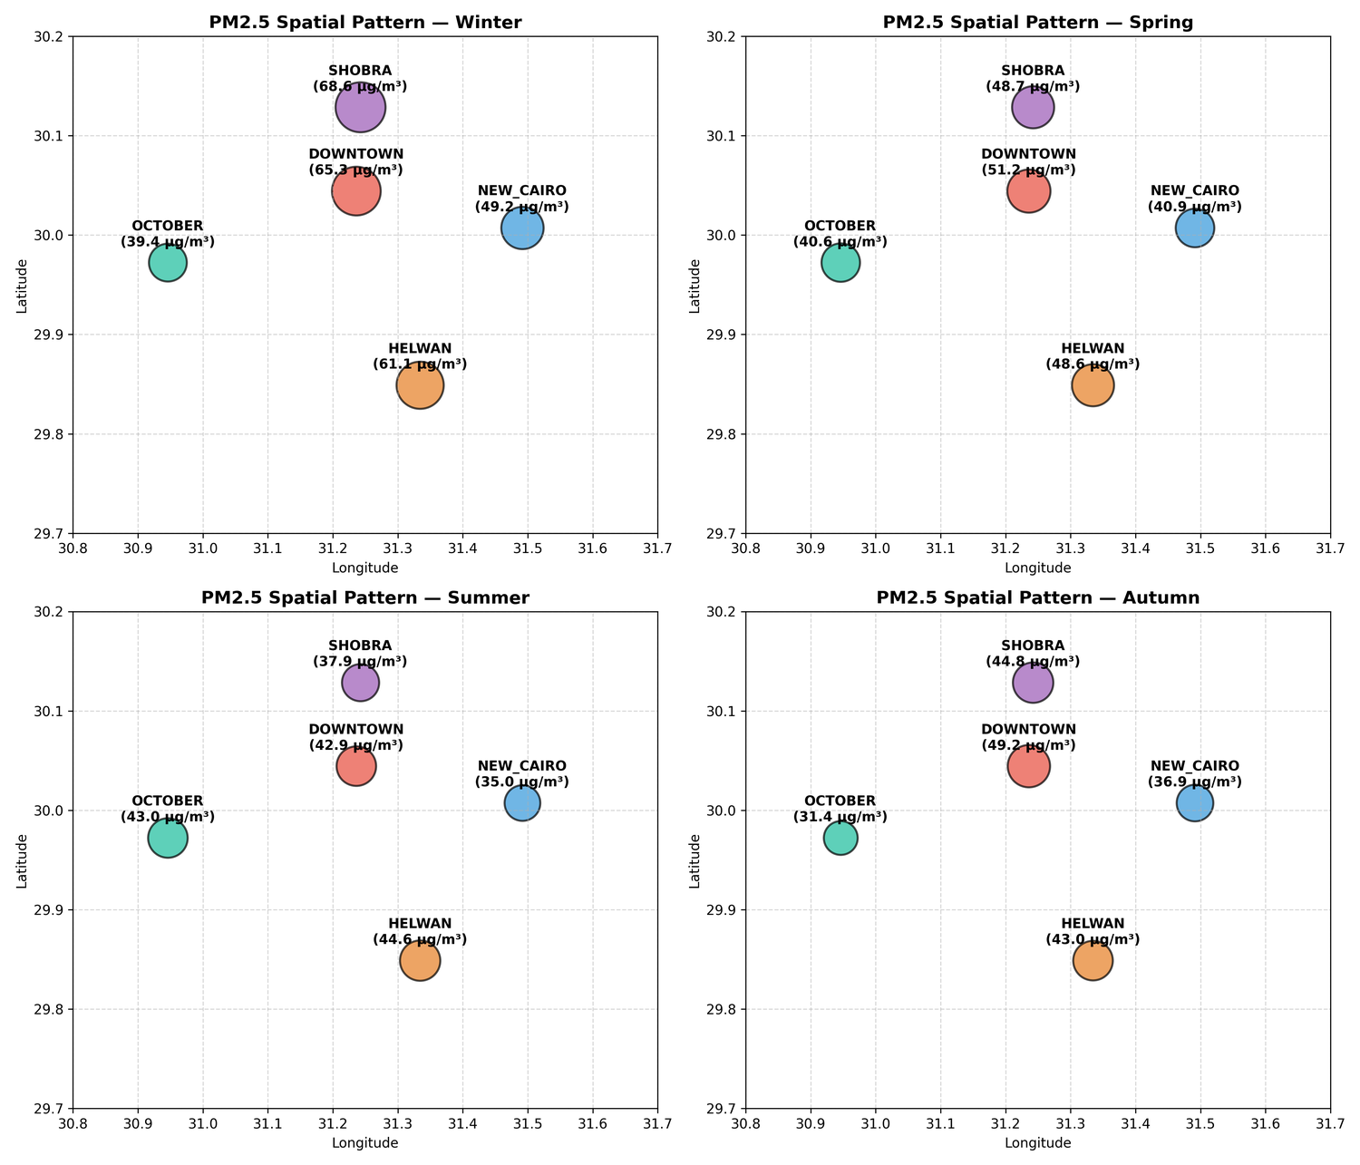
Figure 6. Seasonal mean PM2.5 (corrected) by district (Task 5).
- Winter (inversion): worst in Shobra, Downtown and Helwan, where traffic and industrial emissions are trapped near the surface.
- Spring (Khamsin): values converge across districts (40.6 to 51.2 µg/m³) as the winter peaks fade; October is the only district where spring is higher than winter.
- Summer and autumn: PM2.5 reaches its annual low in summer in Downtown, New Cairo and Shobra, and in autumn in Helwan (43.0). October is the exception: it peaks in summer (43.0) and drops to 31.4 in autumn, the cleanest value of any district and season.
Feature-importance pre-screening. A LightGBM regressor (default settings, gain importance) was fitted on the final dataset (5,480 rows, 97 numeric features) with pm2_5_corrected as the target. pm2_5_corrected_lag_1d, the previous day's PM2.5, dominates with a gain more than ten times that of the next feature. Wind variables follow (wind_speed_10m_max, wind_speed_10m_mean, wind_dir_cos), then humidity, uv_index, temperature variability and month. The Task 3 features inversion_proxy_v2, inversion_proxy and dust_transport_proxy, and the satellite columns s5p_no2_col and s5p_o3_col, also reach the top 25. Week 3 should prioritise the previous-day PM2.5 value together with the wind and humidity features.
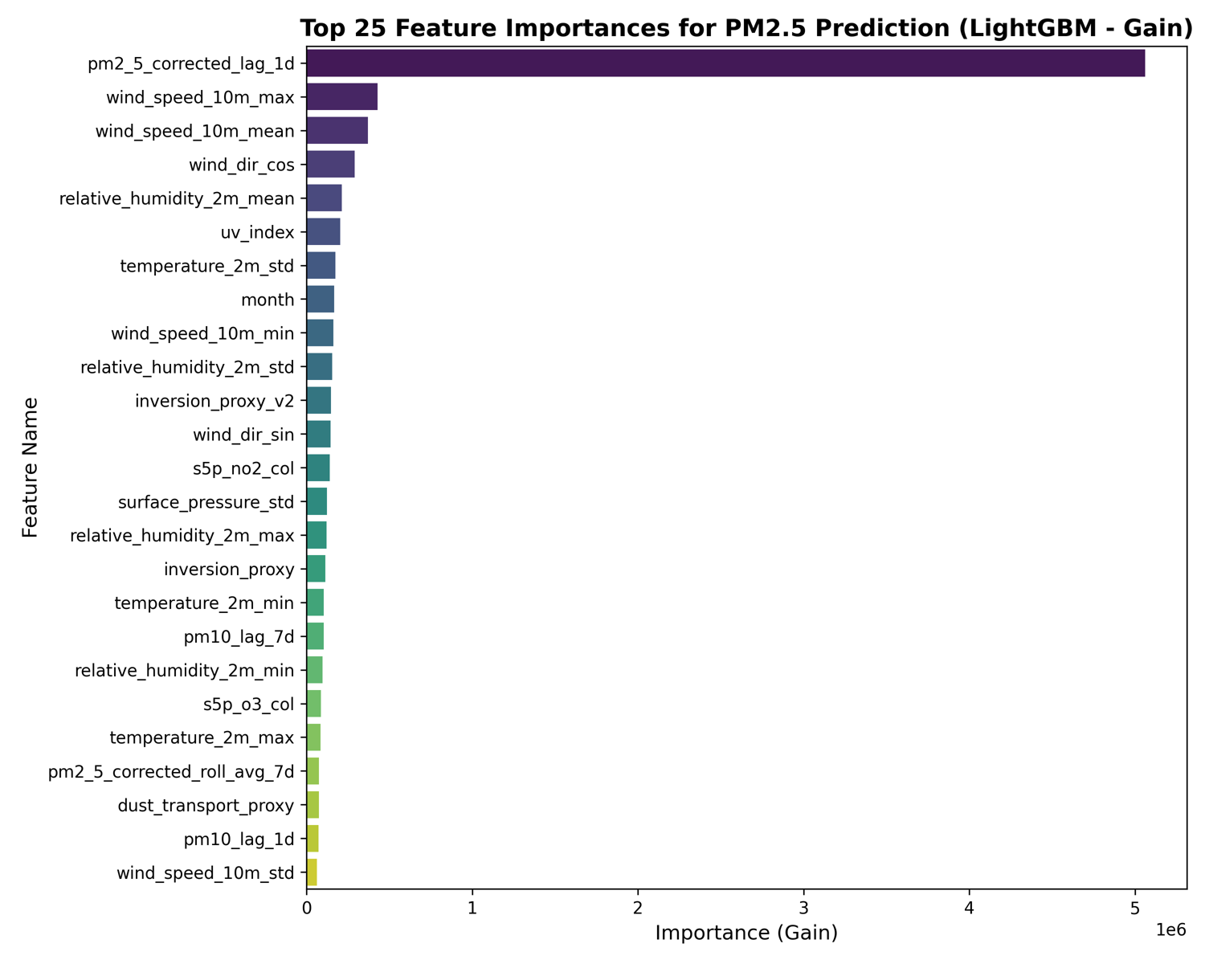
Figure 7. Top 25 features by LightGBM gain, target pm2_5_corrected (Task 5).
Importances come from a single default-settings fit on the final dataset, with the rolling averages recomputed on previous days only.

5.2 Pollutant-weather dashboard (Task 6)
The interactive dashboard (cairo_air_quality_dashboard.html, standalone Plotly) contains PM2.5 vs wind speed and NO2 vs temperature scatter plots coloured by district with a district filter, PM2.5 box plots by season and by Khamsin flag, and the Spearman correlation heatmap. Static snapshots are shown below.
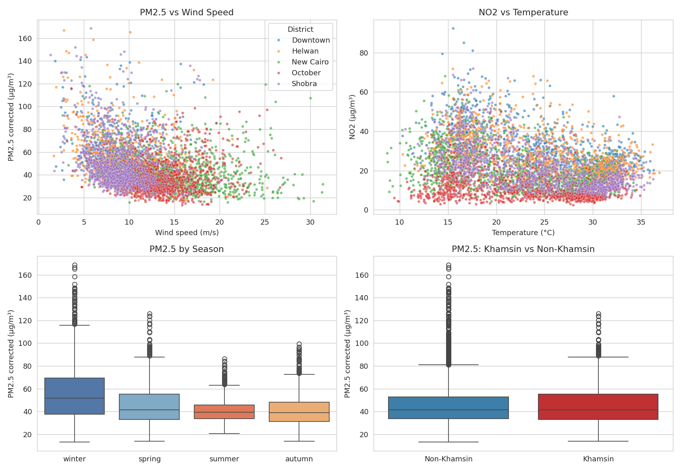
Figure 8. Dashboard panels: scatter plots (top) and box plots by season and Khamsin flag (bottom).
- PM2.5 falls as wind speed rises (pooled Spearman r = -0.37), consistent with dispersion. NO2 falls with temperature (r = -0.30).
- Winter has the highest PM2.5 and the widest spread, and the Khamsin flag is associated with a visible shift in the PM2.5 distribution.

5.3 Weekday vs weekend pollution (Task 6)
Means by day of week for each district, with Friday and Saturday (the Egyptian weekend, shaded) compared against the other five days.
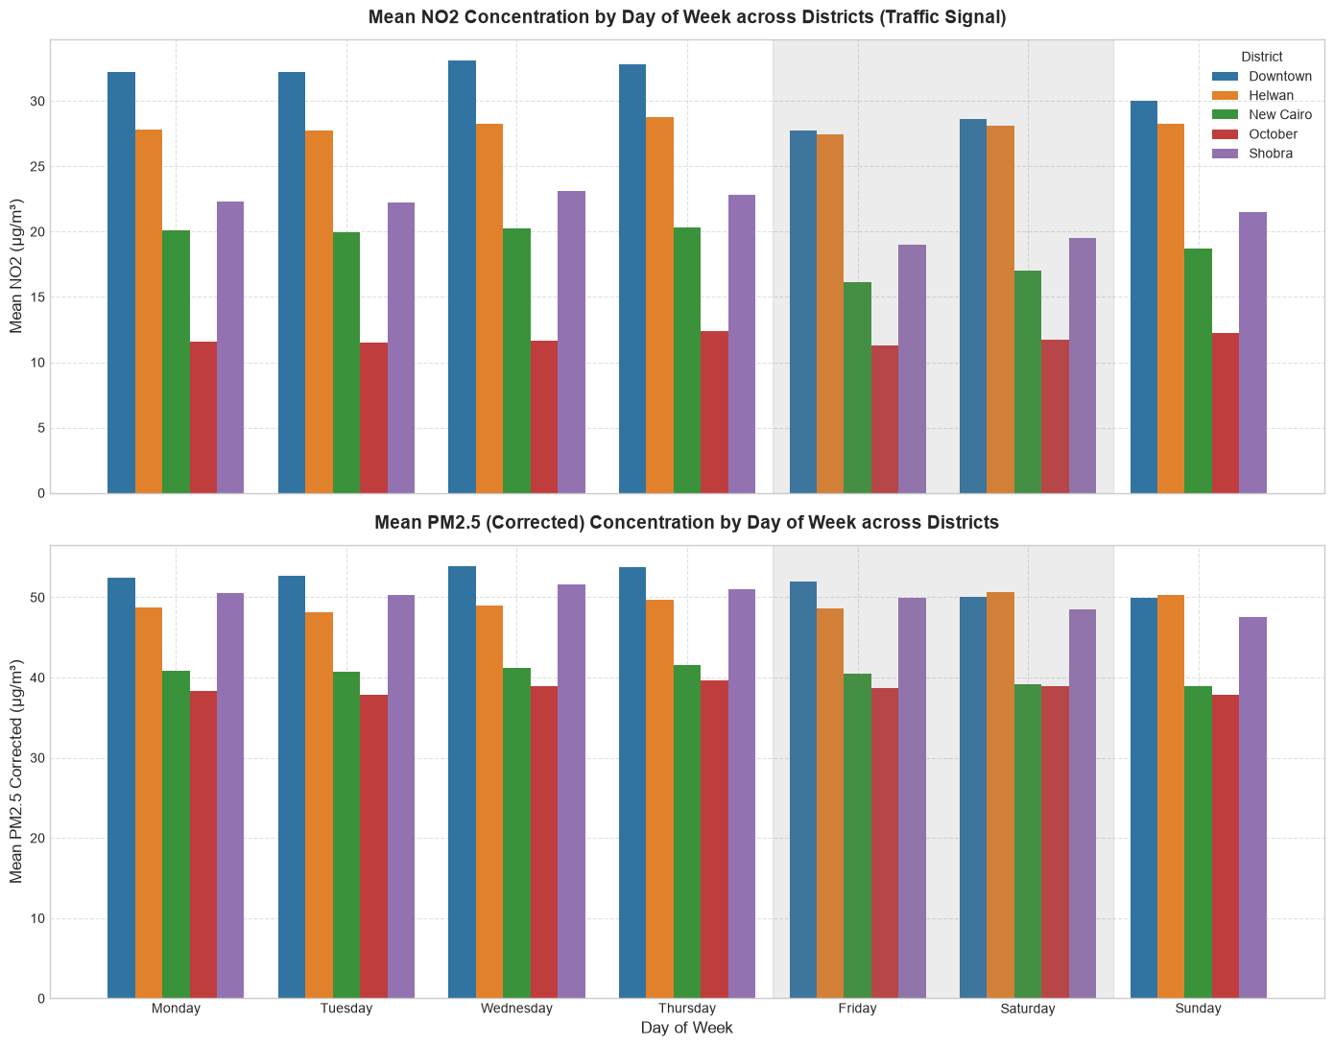
Figure 9. Mean NO2 (top) and PM2.5 (bottom) by day of week across districts. Friday and Saturday are shaded.
District | NO2 weekday | NO2 weekend | NO2 change | PM2.5 weekday | PM2.5 weekend | PM2.5 change
Downtown | 32.08 | 28.15 | -12.3% | 52.52 | 51.03 | -2.8%
Helwan | 28.17 | 27.75 | -1.5% | 49.20 | 49.66 | +0.9%
New Cairo | 19.87 | 16.60 | -16.5% | 40.67 | 39.82 | -2.1%
October | 11.87 | 11.53 | -2.9% | 38.55 | 38.78 | +0.6%
Shobra | 22.37 | 19.25 | -14.0% | 50.22 | 49.25 | -1.9%
Weekend = Friday and Saturday; weekday = Sunday to Thursday. Values in µg/m³.
- NO2 shows a clear traffic signal in Downtown, Shobra and New Cairo, dropping 12-17% on weekends.
- Helwan and October show almost no weekly cycle (-1.5% and -2.9%), which fits industrial or background-dominated NO2 rather than commuter traffic.
- PM2.5 barely changes (within about ±3%), so it behaves as a regional/background signal and is_weekend should matter mainly for NO2-related modelling.

